**Industry Data**

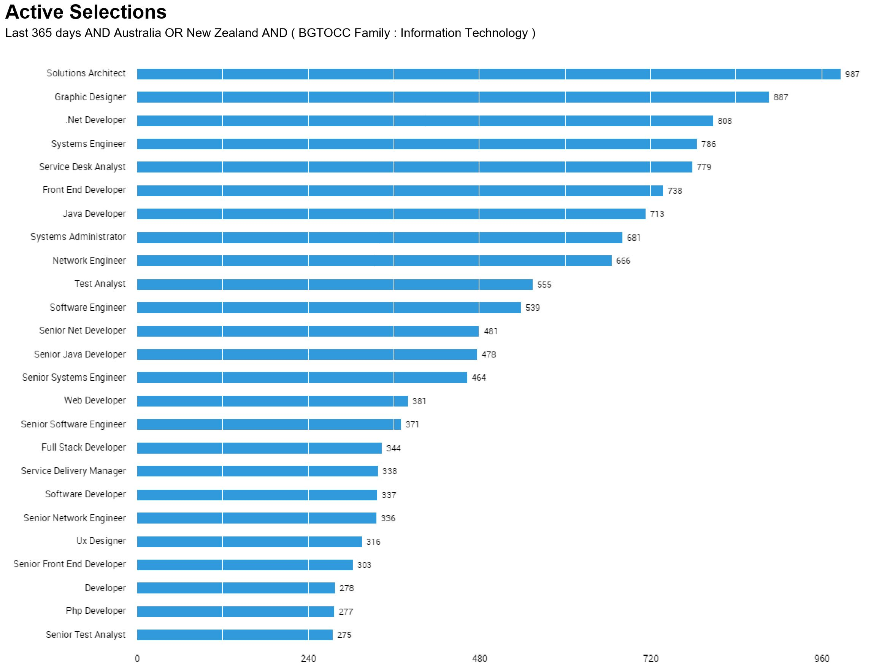This chart displays the ‘top titles' within the information technology sector as of March 24th 2017.

The titles that our group have mentioned to be their ideal roles include the following:   
Senior Software Engineer - Harley Tuleja  
C++ Engineer - Steven Flanigan  
Mobile App Developer - Liam Hackett  
Network Architect - Daniel Mammone  
Scientiﬁc Programmer - MaryJane Amos

Senior Software Engineer was the sixteenth most prevalent role according to the Labour Insight Data with a total of 371 job postings.

C++ Engineer was not on the top list of roles in the chart as it is a speciﬁc role and program. Software engineers however were on this list and ranked 11th with 539 job listings with that title.   
Mobile App Developer as a speciﬁc role was not on the list however there were several mentions of developer positions throughout the list. They included Net, java, Senior Net, Senior Java, Web, Full stack, Software, senior front end, php and general developer roles.   
Network Architect was not speciﬁed on the chart by Labour insight however the number one most sort after role was ‘solutions architect’ it had 987 roles for that title, the ninth most sort after role was Network engineering which had 666 roles being oﬀered with that title.   
Scientiﬁc Programmer was not on the list of top titles however as with this role it is closely related to developing and engineering which were all listed in the top roles according to this chart.

**General Skills**

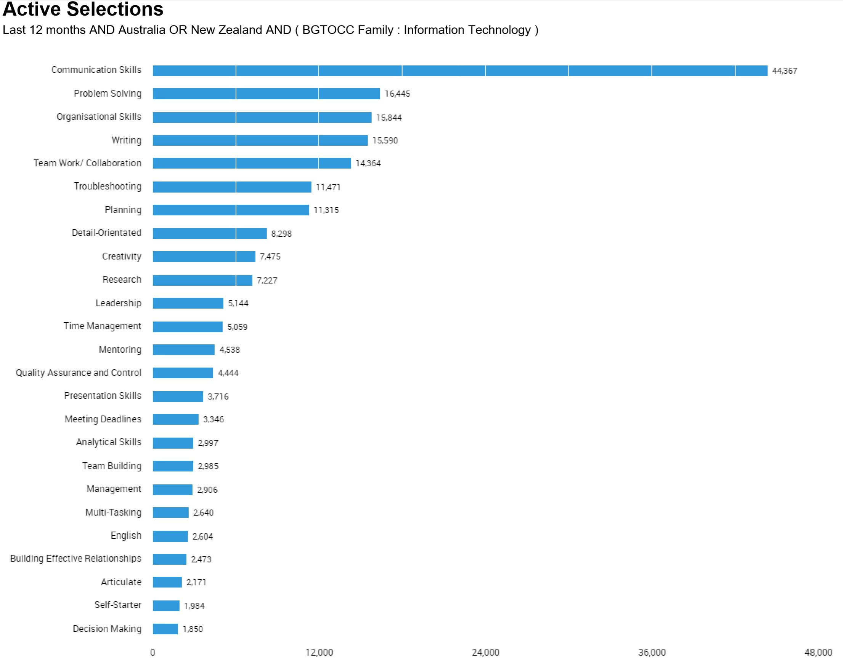This chart displays the ‘Skills in Greatest Demand (Baseline Skills)' within the information technology sector as of Mar. 01, 2017 - Feb. 28, 2018.

General skills required include (Skill set) :- Communication Skills, verbal and written  
 - Problem solving skills ( debugging and forming solutions)  
 - Written skills   
 - Research   
 - Analytical skills  
 - Troubleshooting   
 - Team work

All our jobs had a common skill requirement of communication, employers either specified verbal communication or written communication. This was seen with the chart as over 44,000 job listings had this as their required general skill, employers really value communication as it’s necessary in any job. Problem solving was the second on this chart and had 16,445 job listings that made a mention of the skill. Problem solving in our skill set was evident however it was presented with other synonyms such as debugging or implementing solutions. It was also interesting to observe that the chart had trouble shooting listed as the sixth skill most employers look for. It can be argued that troubleshooting is another word for problem solving. The problem solving process requires trouble shooting and are connected to each other. Our skill set included trouble shooting and problem solving as mentioned earlier. Analytical skills and research were also part of our group’s skill set, it can also be argued that these skills have a relationship to the skill of problem solving as they are often used to problem solve. The most important skills that employers look for according to this chart are communication and problem solving as a high number of job listings have stated these terms in their descriptions or advertisements.

The three highest ranked general skills which are not in our required skill set are:

Organisational Skills with 15,844 jobs  
Writing with 15,590 jobs  
Planning with 11,471 jobs

**IT Specific Skills.**

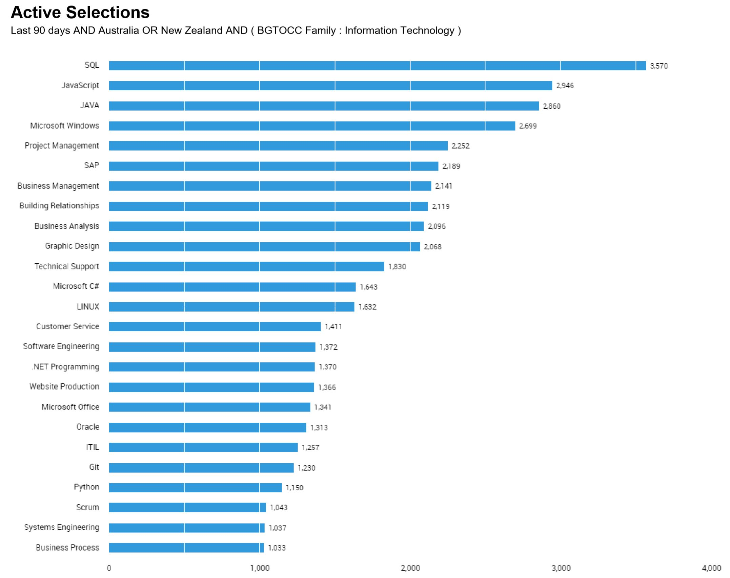This chart displays the ‘Skills in Greatest Demand (Specialised Skills)' within the information technology sector as of Dec. 24, 2017 - Mar. 23, 2018 .

IT speciﬁc skills required (Skill set) - Coding   
 - C++   
 - Linux  
 - Python   
 - VMware   
 - SD WAN experience   
 - AWS   
 - Azure  
 - C#  
 - WPF  
 - MVVM  
 - UX design

The data chart by labour insight lists the top specialist skills in demand according to the ﬁlters applied during the search. There was a total of 27,435 jobs with these skills speciﬁc to IT. The top skill was SQL which had 3,570 job listings, none of our jobs required SQL as a specialised skill. C++ was among our skill set required for a few jobs however that skill was not on the chart there was however Microsoft C# with 1643 job listings specifying it as a required skill for the role. Linux was among the required skills for 1,632 positions, Linux by this chart is a highly sort after skill that would expand employment opportunities. Python is also a popular skill amongst employees with 1,150 job listings with this requirement. VMware was not included in this list as it is a software company that specialises in virtual machines. Familiarity with such software is not common due to it’s uniqueness to a few areas in IT. SDWAN (software-deﬁned networking in a wide area network) was also not included in the top list of required skills. AWS ( amazon web services) failed to make the list also, this may be due to it’s specificity. Azure which is a Microsoft cloud computing service was not included in this chart as well. Windows Presentation Foundation

WFP, UX design and Model–view–viewmodel (MVVM) a software architectural pattern were not among the specialised skills that most employers mentioned in their job listings.   
  
The three highest ranked IT-speciﬁc skills which are not in our required skill set are:

SQL with 3,750 job listings   
JavaScript with 2,946 job listings   
JAVA with 2,860 jobs

**Reflection**

After looking at the burning glass data it is evident that speciﬁc jobs are more in demand than others particularly developing, analyst and engineering roles. My job title in particular was not present on this list. The title of scientiﬁc programmer is more speciﬁc to the scientiﬁc sector therefore it is not a popular ﬁeld for IT, I do see that there are aspects of the popular roles included in my ideal job such as analyses and to some degree developing. When it comes to job security and gaining employment it makes sense to consider other roles which are known to be popular and in demand, however my opinion of my ideal job has not changed. I believe it is a niche industry especially when it comes to the IT portion of science and research. This does not mean there aren’t such roles. The top or most common roles that relate to information technology are included in this list, there are so many less popular roles that didn’t make it to the list for that reason. My overall opinion about my ideal role remains unchanged however I’m now more aware that it is not as popular as other roles and may prove to be a challenge to obtain. -MJ

Even after looking through the burning glass data I am still very happy with the “ideal job” that I have found. Although being a senior software engineer is not the most sought after job according to some of the burning glass data it is still very popular with , as I believe the company values of Blizzard are in line with my own values, and that is more important to me than being in demand.

Software engineers while not the highest sought after profession according to BG they are still very high up on the list, this is encouraging as I believe that if I work towards this goal I won’t ever have to worry about work if I can’t get a job with Blizzard or a similar game developer. - Harley